**Clarification required in Shopping Cart**

**Add to Cart**

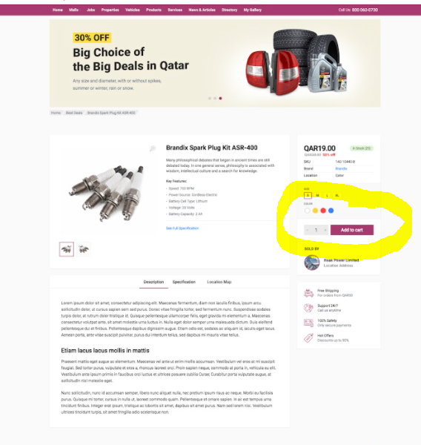

* Here we will be using below apis to add into cart-- Yes
* <http://175.41.176.135:3000/apidoc/#api-Shopping_Cart-PostV1UsersUser_idCart>
* <http://175.41.176.135:3000/apidoc/#api-Shopping_Cart-PostV1UsersUser_idCartService>

**Shopping Cart**

* Here we need to display Products and services in two different tabs, without any checkboxes. Yes
* <http://175.41.176.135:3000/apidoc/#api-Shopping_Cart-GetV1UsersUser_idCart>
* <http://175.41.176.135:3000/apidoc/#api-Shopping_Cart-GetV1UsersUser_idCartService>
* Quantity part is there, do we have separate API for product and services to update based on the quantity(Currently only Product cart update is there) :- Can u same for Product/Service
* <http://175.41.176.135:3000/apidoc/#api-Shopping_Cart-PutV1UsersUser_idCart>
* In Displaying the Cart Total, From the API, Do we get the shipping charge?:- Here we don’t need
* Products and services, both together will do the checkout? Yes

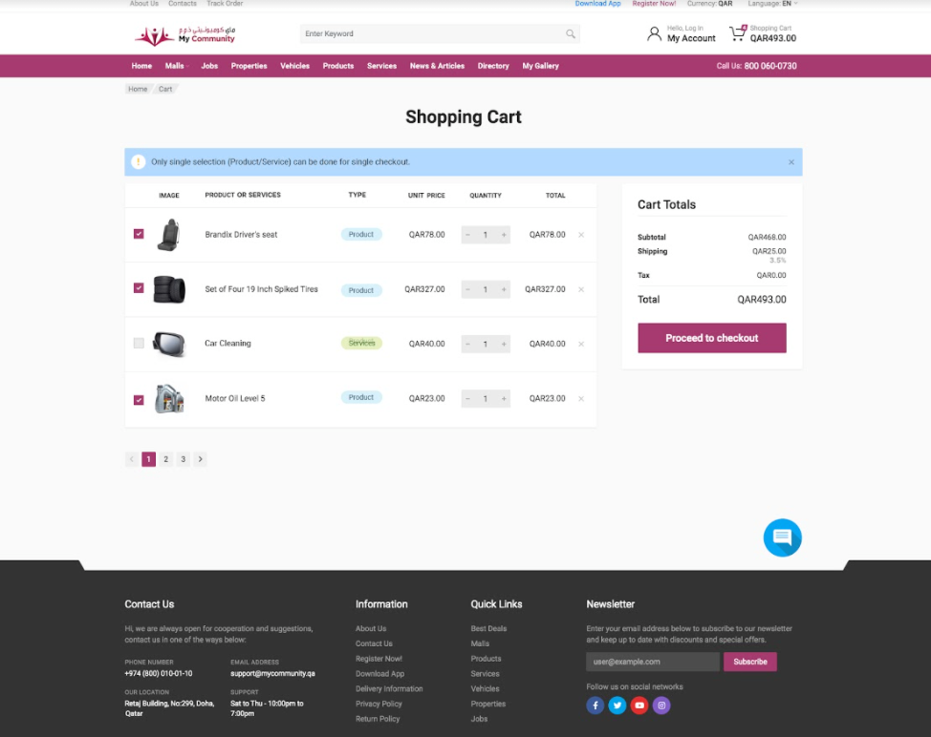

**Check OUt**

* Order- Products-Create Order(for user)-> once when we click proceed to checkout have to call this api and have to show the order number in screen
* Here we will be displaying the products added in the cart(both products and services will be listing), So here below two api will be using—Yes
* GetOrders(For Buyer)-- for buyer all details will come—Indvidual User
* GetOrders(For Seller)—Corporate User
* Cancel order an API (Cancel Order(for Admin and buyer))
* While adding new shipping Address, we can call the Address API

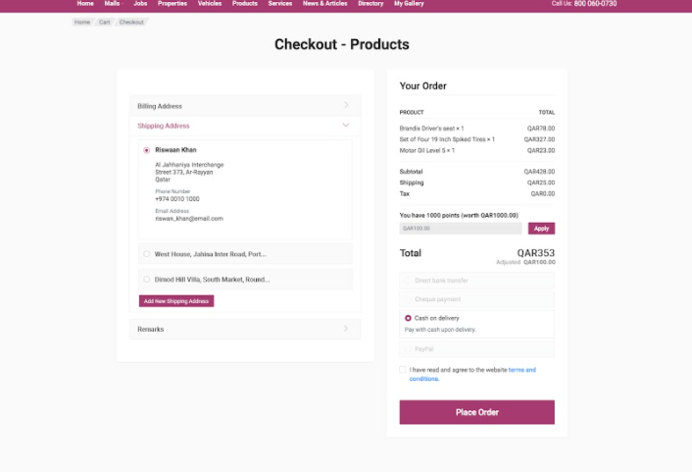

**Best Deal**

* Clarification Required
* We are not creating any best deals(Product/Services) from our web—Currently No

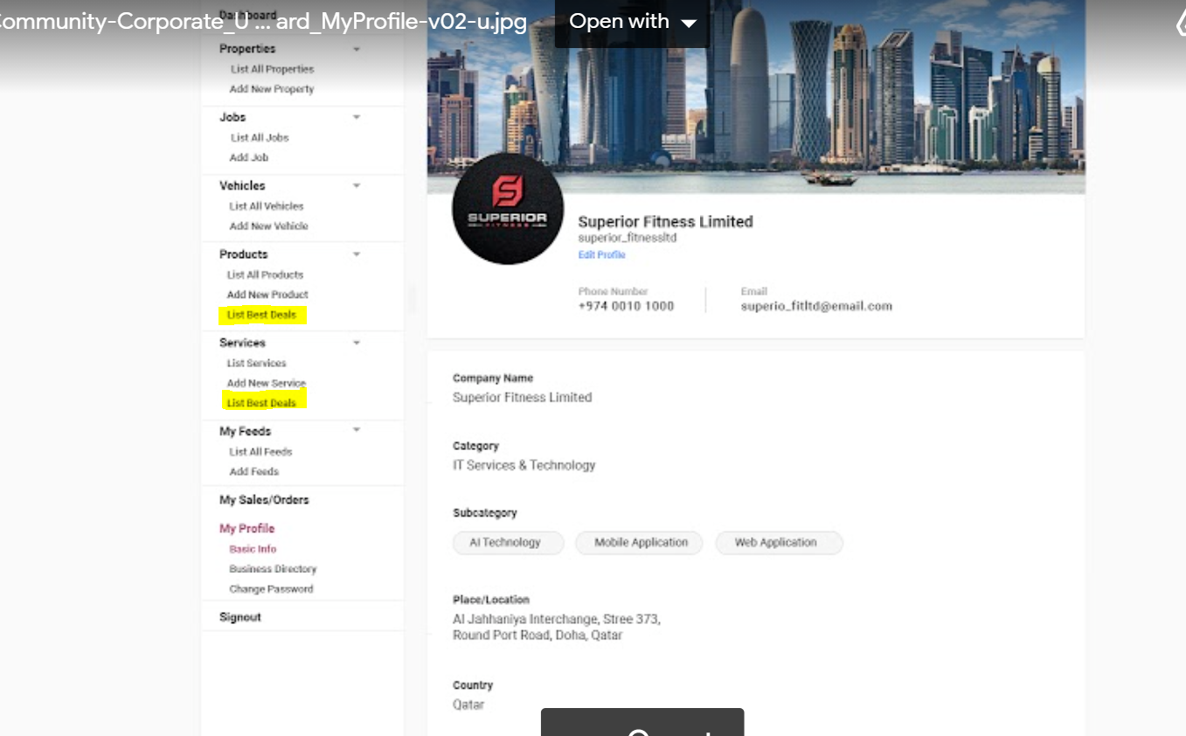

* Which API are we using to list the best deals in Products and Services of dashboard?

Using the List Products With BestDeals True

**Redeem Points**

* As discussed in last meeting, we will be showing the redeem points in below screen**.**
* **How we get the redeem points?**

Using the API GetMy Profile-->Available redeem point

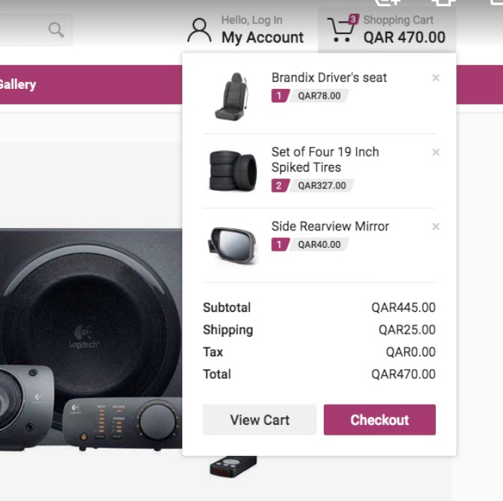

**Profile Page Details**

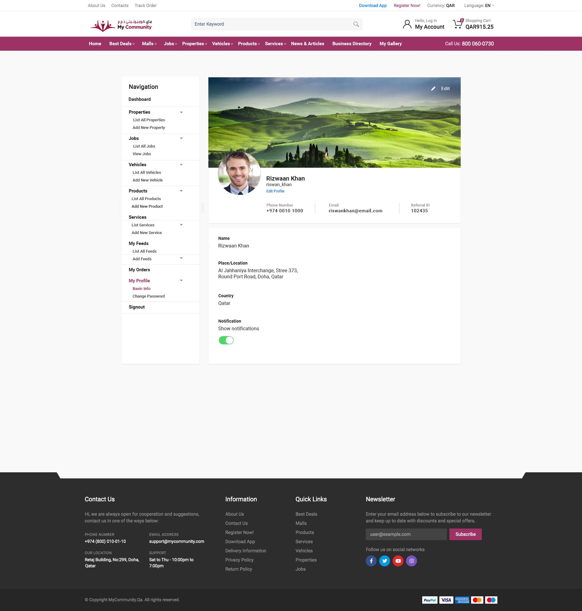

* <http://175.41.176.135:3000/apidoc/#api-User_Accounts-GetV1UsersProfilesMe> - User details- no categoryName, subCategoryName and industryName. No location details in both corporate or individual instead we are only getting the ID of it, so we need to fetch each separately. It can delay page loading time more. It would be better to get in a single API with name and ID together.

Once user login, we can save the details in session rit… there we can keep this data names

* Notification individual update API is needed (currently API available to update all fields in update user, but with mandatory fields in it)

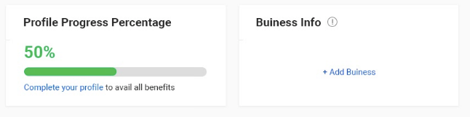

* From where we can get the profile progress (currently not available with API).

Here you can check by using any data getting from Business Info, if not Profile progress Percntage as 50%

* Need more clarification in business info (what is the actual functionality of this business info part in this design)

Corporate more user details need to link

**Vehicle Public Page**

In-vehicle details page new design need to show the profile pic of the dealer in the contact part

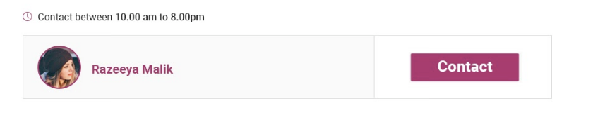

<http://175.41.176.135:3000/apidoc/#api-Vehicles-GetV1VehiclesSlugsSlug> - Vehicle details on public page- no contact profile pic.

If a profile pic is there it should list it seems in APi.

**Gallery**

-In gallery listing for public, authentication error is being returned. The Api documentation doesn’t mention a user token to add while requesting—will do the correction today

<http://175.41.176.135:3000/apidoc/#api-Galleries-GetV1GalleriesAlbums>

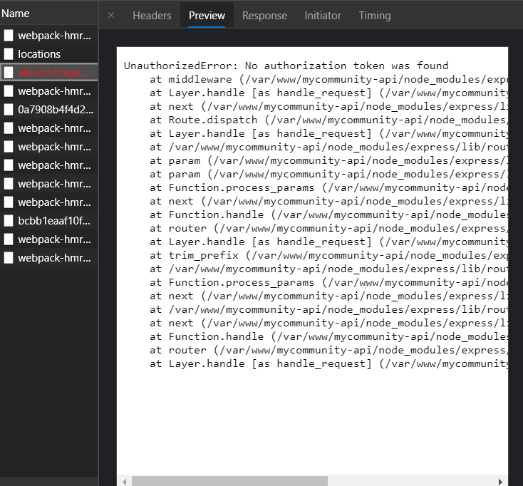

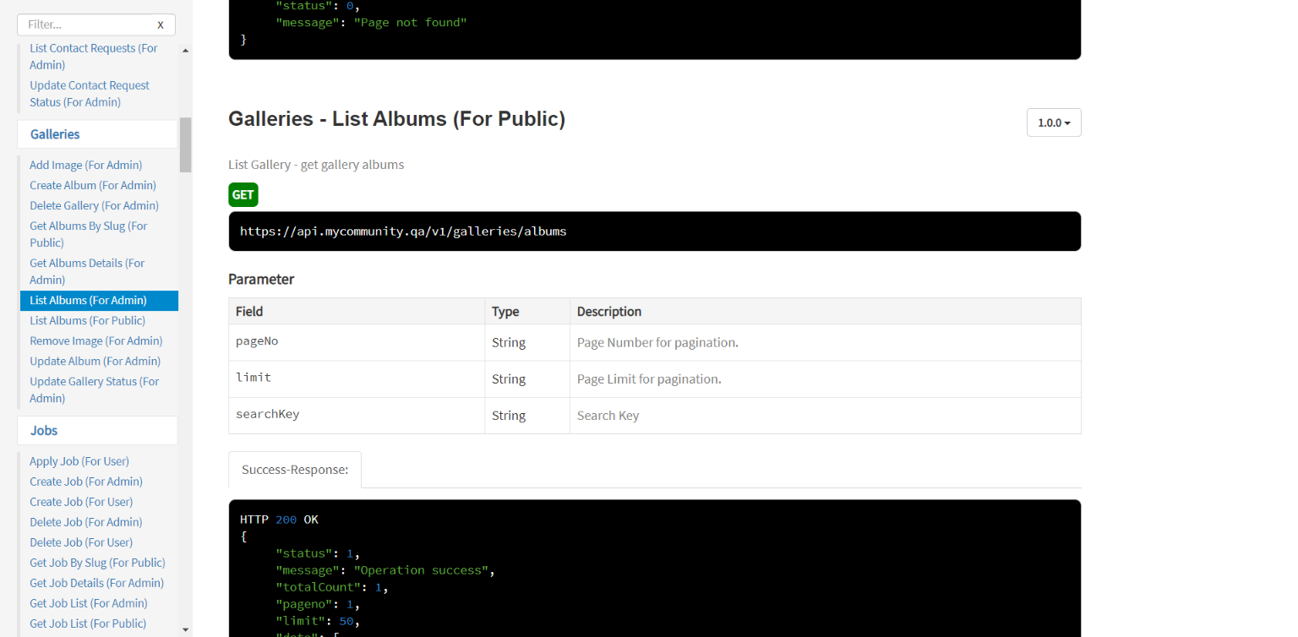

- In new gallery API, No location data is being returned—No need to show Location data in Gallery,just images alone